School of Computer Applications
Department of Master of Computer Applications
SEM Examination Summer – 2026
Semester – II
Class Test – II Practical Exam
Sub Code: 240110203 | Division: D | Total Marks: 50 (including VIVA)
Sub Name: Object Oriented Programming with JAVA (OOPJ)
SET-2
A | LinkedList + Random Access File [20 Marks]  Write a Java program to store and retrieve Book records using LinkedList (List Interface) and RandomAccessFile.  The program should perform the following:  • Accept details of 4 books (Book ID: int, Title: String 20 chars, Price: double) from the user.  • Store them in a LinkedList<Book> (create a Book class with constructor).  • Write all records into 'books.dat' using RandomAccessFile in 'rw' mode.  – Each record: 4 bytes (int) + 40 bytes (padded String) + 8 bytes (double) = 52 bytes.  • Read and display a specific book record by its record number using seek().  • Display all records by reading sequentially. | 20
B | Swing – Temperature Converter [20 Marks]  Design a Temperature Converter application using Java Swing:  • JTextField for entering the temperature value.  • JComboBox for selecting conversion: Celsius to Fahrenheit, Celsius to Kelvin, Fahrenheit to Celsius, Fahrenheit to Kelvin.  • JButton — 'Convert' and 'Clear'.  • JLabel to display the converted result with proper unit.  • JLabel to show error message for invalid input ('Please enter a valid number.').  • On Convert → parse input, apply correct formula, display rounded result in result label.  • On Clear → reset all fields.  • Use FlowLayout with appropriate spacing.  Expected Output:  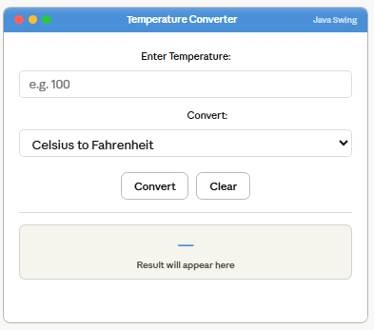 | 20
 | Viva | 10

